1. **Which two statements about DSL are true? (Choose two.)**
   * **local loop can be up to 3.5 miles (5.5km)\***
   * **user connections are aggregated at a DSLAM located at the CO\***
2. **Which two statements are true regarding a PPP connection between two Cisco routers? (Choose two.)**
   * **LCP tests the quality of the link.\***
   * **LCP manages compression on the link.\***
3. **A network administrator is asked to design a system to allow simultaneous access to the Internet for 250 users. The ISP can only supply five public IP addresses for this network. What technology can the administrator use to accomplish this task?**
   * **port-based Network Address Translation\***
4. **Refer to the exhibit. An administrator is configuring NAT to provide Internet access to the inside network. After the configuration is completed, users are unable to access the Internet. What is the cause of the problem?**  
   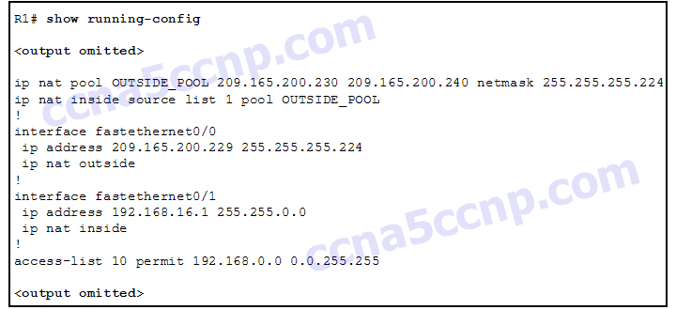
   * **The NAT inside source command is referring to the wrong ACL.\***
5. **What is the expected behavior of an ADSL service?**
   * **The download rate is faster than the upload rate.\***
   * **The upload rate is faster than the download rate.\***
6. **A network administrator is troubleshooting the dynamic NAT that is configured on router R2. Which command can the administrator use to see the total number of active NAT translations and the number of addresses that are allocated from the NAT pool?**
   * **R2# show ip nat statistics\***
7. **Which type of traffic would most likely have problems when passing through a NAT device?**
   * **IPsec\***
8. **Refer to the exhibit. The inside local IP address of PC-A is 192.168.0.200. What will be the inside global address of packets from PC-A after they are translated by R1?**  
   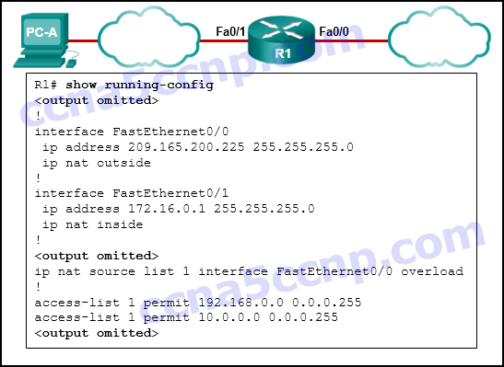
   * **209.165.200.225\***
9. **Refer to the exhibit. What kind of NAT is being configured on R1?**  
   https://ccnav6.com/wp-content/uploads/2016/02/i212351v1n1_Question-7.png
   * **port forwarding\***
10. **What benefit does NAT64 provide?**
    * **It allows sites to connect IPv6 hosts to an IPv4 network by translating the IPv6 addresses to IPv4 addresses.\***
11. **What are three benefits of using Frame Relay for WAN connectivity? (Choose three.)**
    * **one physical interface that can be used for several circuits\***
    * **mature technology\***
    * **reasonable cost\***
12. **The DLCI number assigned to a Frame Relay circuit is to be manually added on a point-to-point link. Which three subinterface commands could be used to complete the configuration? (Choose three.)**
    * **bandwidth kilobits\***
    * **frame-relay interface-dlci dlci\***
    * **ip address ip-address mask\***
13. **Which command can be used to check the information about congestion on a Frame Relay link?**
    * **show frame-relay pvc\***
14. **A network administrator is configuring a PPP link with the commands:**  
    **R1(config-if)# encapsulation ppp**  
    **R1(config-if)# ppp quality 70**

**What is the effect of these commands?**

* + **The PPP link will be closed down if the link quality drops below 70 percent.\***

1. **Refer to the exhibit. A network administrator has implemented the configuration in the displayed output. What is missing from the configuration that would be preventing OSPF routing updates from passing to the Frame Relay service provider?**  
   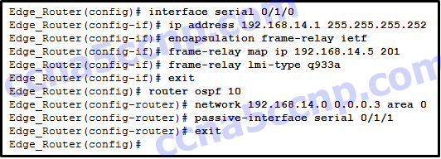
   * **The broadcast keyword has not been issued.\***
2. **What is a characteristic of Frame Relay that allows customer data transmissions to dynamically “burst” over their CIR for short periods of time?**
   * **The physical circuits of the Frame Relay network are shared between subscribers and there may be times when unused bandwidth is available.\***
3. **Which broadband technology would be best for a small office that requires fast upstream connections?**
   * **fiber-to-the-home\***
4. **What is the protocol that provides ISPs the ability to send PPP frames over DSL networks?**
   * **PPPoE\***
5. **Which technology requires the use of PPPoE to provide PPP connections to customers?**
   * **DSL\***
6. **Why is it useful to categorize networks by size when discussing network design?**
   * **The complexity of networking infrastructure will vary according to the number of connected devices.\***
7. **A company connects to one ISP via multiple connections. What is the name given to this type of connection?**
   * **dual-homed\***
8. **What is one advantage to designing networks in building block fashion for large companies?**
   * **failure isolation\***
9. **Which network module maintains the resources that employees, partners, and customers rely on to effectively create, collaborate, and interact with information?**
   * **data center\***
10. **A group of Windows PCs in a new subnet has been added to an Ethernet network. When testing the connectivity, a technician finds that these PCs can access local network resources but not the Internet resources. To troubleshoot the problem, the technician wants to initially confirm the IP address and DNS configurations on the PCs, and also verify connectivity to the local router. Which three Windows CLI commands and utilities will provide the necessary information? (Choose three.)**
    * **ipconfig\***
    * **nslookup\***
    * **ping\***
11. **A team of engineers has identified a solution to a significant network problem. The proposed solution is likely to affect critical network infrastructure components. What should the team follow while implementing the solution to avoid interfering with other processes and infrastructure?**
    * **change-control procedures\***
12. **Which troubleshooting tool would a network administrator use to check the Layer 2 header of frames that are leaving a particular host?**
    * **protocol analyzer\***
13. **Which two specialized troubleshooting tools can monitor the amount of traffic that passes through a switch? (Choose two.)**
    * **NAM\***
    * **portable network analyzer\***
14. **Refer to the exhibit. Which two statements describe the results of entering these commands? (Choose two.)**  
    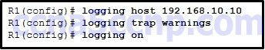
    * **R1 will send system messages of levels 0 (emergencies) to level 4 (warnings) to a server.\***
    * **The syslog server has the IPv4 address 192.168.10.10.\***
15. **Refer to the exhibit. On the basis of the output, which two statements about network connectivity are correct? (Choose two.)**  
    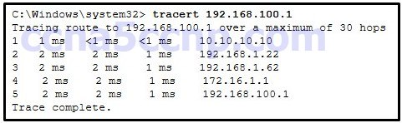
    * **There is connectivity between this device and the device at 192.168.100.1.\***
    * **There are 4 hops between this device and the device at 192.168.100.1.\***
16. **Which statement is a characteristic of SNMP MIBs?**
    * **The NMS must have access to the MIB in order for SNMP to operate properly.\***
17. **Refer to the exhibit. Router R1 was configured by a network administrator to use SNMP version 2. The following commands were issued:**  
    **R1(config)# snmp-server community batonaug ro SNMP_ACL**  
    **R1(config)# snmp-server contact Wayne World**  
    **R1(config)# snmp-server host 192.168.1.3 version 2c batonaug**  
    **R1(config)# ip access-list standard SNMP_ACL**  
    **R1(config-std-nacl)# permit 192.168.10.3**

**Why is the administrator not able to get any information from R1?**  
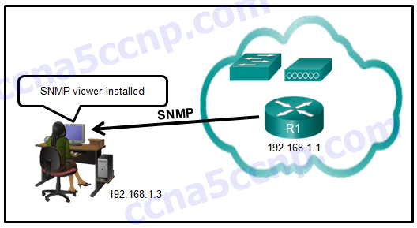

* + **There is a problem with the ACL configuration.\***

1. **What is used as the default event logging destination for Cisco routers and switches?**
   * **console line\***
2. **In the data gathering process, which type of device will listen for traffic, but only gather traffic statistics?**
   * **NetFlow collector\***
3. **Which SNMP message type informs the network management system (NMS) immediately of certain specified events?**
   * **Trap\***
4. **Which three flows associated with consumer applications are supported by NetFlow collectors? (Choose three.)**
   * **accounting\***
   * **billing\***
   * **network monitoring\***
5. **Which algorithm is considered insecure for use in IPsec encryption?**
   * **3DES\***
6. **Which statement describes a characteristic of dense wavelength division multiplexing (DWDM)?​**
   * **It can be used in long-range communications, like connections between ISPs.\***
7. **Two corporations have just completed a merger. The network engineer has been asked to connect the two corporate networks without the expense of leased lines. Which solution would be the most cost effective method of providing a proper and secure connection between the two corporate networks?**
   * **site-to-site VPN\***
8. **Refer to the exhibit. Which IP address is configured on the physical interface of the CORP router?**  
   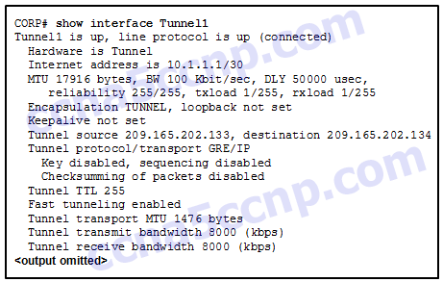
   * **209.165.202.133\***
9. **What are three characteristics of the generic routing encapsulation (GRE) protocol? (Choose three.)**
   * **GRE tunnels support multicast traffic.\***
   * **By default, GRE does not include any flow control mechanisms.\***
   * **Developed by the IETF, GRE is a secure tunneling protocol that was designed for Cisco routers.\***
   * **GRE creates additional overhead for packets that are traveling through the VPN.\***
10. **Which WAN technology can serve as the underlying network to carry multiple types of network traffic such as IP, ATM, Ethernet, and DSL?**
    * **MPLS\***
11. **Which two statements describe remote access VPNs? (Choose two.)**
    * **Client software is usually required to be able to access the network.\***
    * **Remote access VPNs support the needs of telecommuters and mobile users.\***
12. **Which circumstance would result in an enterprise deciding to implement a corporate WAN?**
    * **when its employees become distributed across many branch locations\***
13. **An intercity bus company wants to offer constant Internet connectivity to the users traveling on the buses. Which two types of WAN infrastructure would meet the requirements? (Choose two.)**
    * **public infrastructure\***
    * **cellular\***
14. **Under which two categories of WAN connections does Frame Relay fit? (Choose two.)**
    * **private infrastructure\***
    * **packet-switched\***
15. **What term is used to identify the point where the customer network ends and the service provider network begins?**
    * **the demarcation point\***
16. **Which two characteristics describe time-division multiplexing? (Choose two.)**
    * **Traffic is allocated bandwidth across a single wire based on preassigned time slots.\***
    * **Data capacity across a single link increases as bits from multiple sources are transmitted using interleaved slices of time.\***
17. **A branch office uses a leased line to connect to the corporate network. The lead network engineer confirms connectivity between users in the branch office, but none of the users can access corporate headquarters. System logs indicate that nothing has changed in the branch office network. What should the engineer consider next to resolve this network outage?**
    * **The service provider for the branch office should troubleshoot the issue starting from the point of demarcation.\***
18. **Refer to the exhibit. Which three steps are required to configure Multilink PPP on the HQ router? (Choose three.)**  
    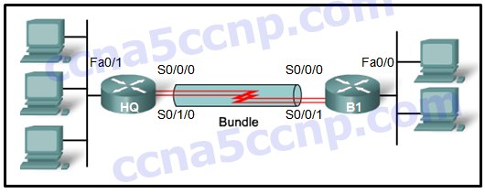
    * **Assign the serial interfaces to the multilink bundle.\***
    * **Enable PPP encapsulation on the serial interfaces.\***
    * **Create and configure the multilink interface.\***
19. **Refer to the exhibit. A network administrator discovers that host A is having trouble with Internet connectivity, but the server farm has full connectivity. In addition, host A has full connectivity to the server farm. What is a possible cause of this problem?**  
    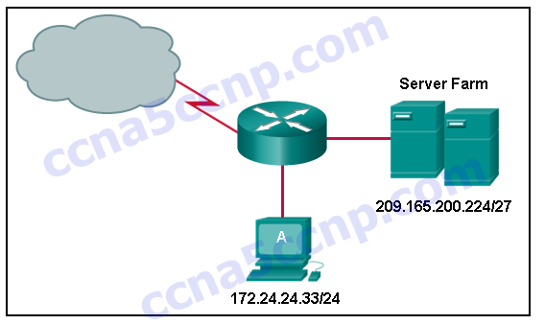
    * **NAT is required for the host A network.\***
20. **Refer to the exhibit. H1 can only ping H2, H3, and the Fa0/0 interface of router R1. H2 and H3 can ping H4 and H5. Why might H1 not be able to successfully ping H4 and H5?**  
    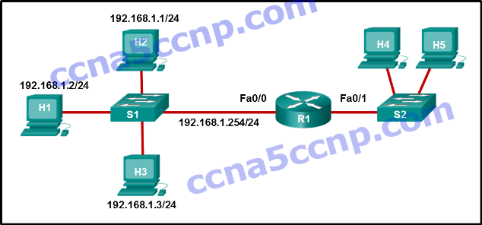
    * **Host H1 does not have a default gateway configured.\***
21. **What is required for a host to use an SSL VPN to connect to a remote network device?**
    * **A web browser must be installed on the host.\***
22. **What type of information is collected by Cisco NetFlow?**
    * **traffic statistics\***
23. **Match the characteristic to the appropriate authentication protocol. (Not all options are used.)**

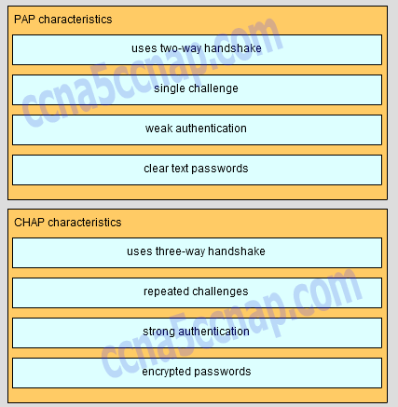

PAP characteristics

- uses two-way handshake

- single challenge

-weak authentification

-clear text passwords

CHAP charactristics

-uses three-way handshake

-repeated challenges

-strong authentification

-encrypted paswords

1. **Which SNMP message type informs the network management system (NMS) immediately of certain specified events?**
   * **Trap\***

**56. Which SNMP message type informs the network management system (NMS) immediately of certain specified events?**

**Trap\***

**57. What is a disadvantage of a packet-switched network compared to a circuit-switched network?**

**higher latency\***\*

**58. Refer to the exhibit. A network administrator is troubleshooting the OSPF network. The 10.10.0.0/16 network is not showing up in the routing table of Router1. What is the probable cause of this problem?**

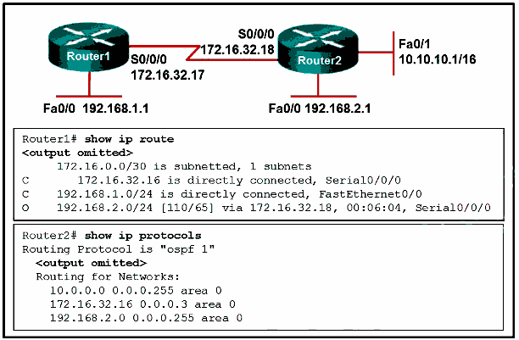

**There is an incorrect wildcard mask statement for network 10.10.0.0/16 on Router2.\***\*

**59. The security policy in a company specifies that the staff in the sales department must use a VPN to connect to the corporate network to access the sales data when they travel to meet customers. What component is needed by the sales staff to establish a remote VPN connection?**

**VPN client software\***

**60. Which three parts of a Frame Relay Layer 2 PDU are used for congestion control? (Choose three.)**

**the FECN bit\***  
**the BECN bit\***   
**the DE bit\***

**61. Which two statements correctly describe asymmetric encryption used with an IPsec VPN? (Choose two.)**   
**Public key encryption is a type of asymmetric encryption.\***  
**Encryption and decryption use a different key.\***

**62. What are two examples of network problems that are found at the data link layer? (Choose two.)**

**framing errors\***   
**encapsulation errors\***

**63. Which IEEE standard defines the WiMax technology?**

**802.16\***

**65. What is the default location for Cisco routers and switches to send critical logging events?**

**syslog server\***   
**console port\***

**66. Which SNMP message type informs the network management system (NMS) immediately of certain specified events?**  
**Trap\***

**67. What is a type of VPN that is generally transparent to the end user?**

**remote access\***  
**site-to-site\***

**68. Refer to the exhibit. Which three events will occur as a result of the configuration shown on R1? (Choose three.)**

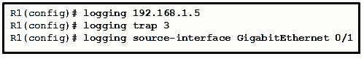

**Messages that are sent to the syslog server will be limited to levels 3 or lower.\***  
**Messages that are sent to the syslog server will use 192.168.1.5 as the destination IP address.\***  
**The syslog messages will contain the IP address the GigabitEthernet 0/1 interface.\***

**69. Which two technologies are implemented by organizations to support teleworker remote connections? (Choose two.)**

**VPN\***  
**CDMA\***  
**IPsec\***

**70. How many 64 kb/s voice channels are combined to produce a T1 line?**

**24\***

**71. Which broadband solution is appropriate for a home user who needs a wired connection not limited by distance?**

**cable\***

**72. What is the purpose of a message hash in a VPN connection?**

**It ensures that the data has not changed while in transit.\***  
**It ensures that the data cannot be read in plain text.\***

**73. Users are reporting longer delays in authentication and in accessing network resources during certain time periods of the week. What kind of information should network engineers check to find out if this situation is part of a normal network behavior?**

**the network performance baseline\***

**74. Which structured engineering desing principle ensures that the network reamins available even under abnormal conditions?**

**resiliency\***

**75. A team of engineers has identified a solution to a significant network problem. The proposed solution is likely to affect critical network infrastruture components. What should the team follow while implementing the solution to avoid interfering with other processes and infrastructure?**

**change-control procedures\***

**76. What is a Frame Relay feauture that supports the IP address-to-DLCI dynamic mapping?**  
**Inverse ARP\***

**77. A small remote office needs to connect to headquarters through a secure IPsec VPN connection. The company is implementing the Cisco Easy VPN solution. Which Cisco Easy VPN component needs to be added on the Cisco router at the remote office?**  
**Cisco Easy VPN Server\***

**78. Which scenario would require the use of static NAT?**  
**when an internal corporate web server needs to be accessed from a home network\***

**79. An organization has purchased a Frame Relay service from a provider. The service agreement specifies that the access rate is 512 kbps, the CIR is 384 kbps, and the Bc is 32 kbps. What will happen when the customer sends a short burst of frames above 450 kbps?**  
**The frames are marked with the DE bit set to 1 and are most likely dropped.\***

**80. What is a Frame Relay feature that supports the IP address-to-DLCI dynamic mapping?**

**Inverse ARP\***

**81. An administrator wants to configure a router so that users on the outside network can only establish HTTP connections to the internal web site by navigating to http://www.netacad.com:8888. Which feature would the administrator configure to accomplish this?**

**port forwarding\***

**82. Which two components are needed to provide a DSL connection to a SOHO? (Choose two.)**

**transceiver\***  
**DSLAM\***

**83. A network engineer is troubleshooting an unsuccessful PPP multilink connection between two routers. That multilink interface has been created and assigned a number, the interface has been enabled for multilink PPP, and the interface has been assigned a multilink group number that matches the group assigned to the member physical serial interfaces. The physical serial interfaces have also been enabled for PPP multilink. Which additional command should to be issued on the multilink interface?**

**clock rate 4000000 \***

**84. What is the international standard defining cable-related technologies?**  
**DOCSIS\***

**82. Which three statements describe characteristics of converging corporate network architecture?**

**Server applications are housed within the phisical corporate network.\***  
**Users connect their own devices to the corporate network.\***  
**Data types include data, and video.\***

**85. Which inefficient feature of time-division multiplexing does statistical TDM overcome?**  
**the unused high speed time slots\***

**86.What are three characteristics of SSL VPNs?**

**authentication can be one way\***  
**authentication uses shared secret or digital cerificates\***  
**an ssl vpn supports web enable applications, e-mail and file sharing\***

**87. A network engineer is designing an IPsec VPN between Cisco routers for a national bank. Which algorithm assures the highest level of confidentiality for data crossing the VPN?**  
**256bit AES\***

**88. By the use of sequence numbers, which function of the IPsec security services prevents spoofing by verifying that each packet is non-duplicated and unique?**

**anti-replay protection\***

**89. A small law firm wants to connect to the Internet at relatively high speed but with low cost. In addition, the firm prefers that the connection be through a dedicated link to the service provider. Which connection type should be selected?**

**leased line\***

**90. How can an administrator configure a Cisco Easy VPN Server to enable the company to manage many remote VPN connections efficiently?**

**by pushing the IPsec security policies to the clients when establishing the tunnel\***

**91. How does QoS improve the effectiveness of teleworking?**

**It provides better service for VoIP and video conferencing applications.\***

**92. Which two networking technologies enable businesses to use the Internet, instead of an enterprise WAN, to securely interconnect their distributed networks? (Choose two.)**

**remote access VPNs\***

**site-to-site VPNs\***

**93. What are two benefits of using SNMP traps? (Choose two.)**

**They eliminate the need for some periodic polling requests.\***

**They reduce the load on network and agent resources.\***

**94. A network engineer has issued the show interfaces serial 0/0/0 command on a router to examine the open NCPs on a PPP link to another router. The command output displays that the encapsulation is PPP and that the LCP is open. However, the IPV6CP NCP is not shown as open. What does the engineer need to configure to open the IPV6CP NCP on the link?**

**Configure an IPv6 address on each interface on the link.\***

**95. What address translation is performed by static NAT?**

**An inside local address is translated to a specified inside global address\***

**96. What are two advantages of using IPv4 NAT? (Choose two.)**

**conserves public IP addresses\***

**provides consistency when an internal corporate IP addressing scheme is being designed\***

**97. Which network design module would not commonly connect to the service provider edge**?

**Remote Access and VPN \*\*\***

**98. Whichtwo types of devices are specific to WAN environments and are not found ona LAN?(Choose two.)**   
**Broadband modem\***  
**CSU/DSU\***

**99. What is a plausible reason that an employee would become a teleworker for a company?**

**to keep employment without having to adhere to company regulations\***

**100. Connecting offices at different locations using the Internet can be economical for a business. What are two important business policy issues that should be addressed when using the Internet for this purpose? (Choose two.)**

**security\*\***   
**addressing\*\***

**101. What is a primary difference between a company LAN and the WAN services that it uses?**

**The company must subscribe to an external WAN service provider.\*\***

**102. A technician at a remote location is troubleshooting a router and has emailed partial debug command output to a network engineer at the central office. The message that is received by the engineer only contains a number of LCP messages that relate to a serial interface. Which WAN protocol is being used on the link?**

**PPP\***

**103. What is a feature of physical point-to-point WAN links?**

**The MAC address is not used in the address field of the point-to-point frame.\***

**104. What are two types of WAN providers? (Choose two.)**

**telephone company\***

**satellite service\***

**105. Which PPP protocol allows a device to specify an IP address for routing over the PPP link?**  
**IPCP\***

**106. In which stage of the troubleshooting process would ownership be researched and documented?**  
**Implement corrective action.\***

**107. A corporation is searching for an easy and low cost solution to provide teleworkers with a secure connection to headquarters. Which solution should be selected?**

**leased line connection\***

**108. Which two statements describe benefits of NAT? (Choose two.)**   
**NAT can provide application port-level multiplexing in order to conserve public IP addresses.\***  
**NAT provides stateful packet filtering features similar to a firewall.\***

**109. What is one drawback to using the top-down method of troubleshooting?**

**the need to check every possible application problem and document it\***

**110. What are three functions provided by syslog service? (Choose three.)**

**to specify the destination of captured messages \***

**to gather logging information for monitoring and troubleshooting \***

**to select the type of logging information that is captured \***

**111. Which two types of equipment are needed to send digital modem signals upstream and downstream on a cable system? (Choose two.)**  
**CMTS\***  
**cable modem\***

**112. What two advantages are associated with Frame Relay WAN technology when compared with leased lines? (Choose two.)**  
**Flexibility\***  
**Cost effectieness\***

**113. Which statement describes an advantage of deploying the Cisco SSL VPN solution rather than the Cisco Easy VPN solution?**

**It supports clientless remote access.\*\***